Title: Absorption and dissemination of internal energy by small PAHs: the role of isomerisation
Speaker: Umesh R. Kadhane, Dept. of Physics, Indian Institute of Space Science and Technology, Thiruvananthapuram, Kerala, INDIA

Survival and evolution of PAHs in the astrophysical environment is governed by their internal energy. Therefore, it has been a common endeavour of numerous investigations to experimentally control internal energy of PAHs and then assess the further utilization of this energy in PAHs. Lately this information has become more valuable, closer to home i.e. in the context of evolution of organics in our solar system, particularly for the formation of prebiotic molecules.
Conventionally, such measurements are done with the help of techniques using photo-excitations like PEPICO/iPEPICO, multiphoton induced dissociation, etc. At IIST we started with the more challenging task of using fast charged particle collisions with PAH for the same purpose. The existence of collective electronic excitations in PAHs assisted us in determining the internal energy distributions and we could understand how this energy is further utilized in the molecule. This work unravelled interesting aspects of isomerisation, statistical and non-statistical dissociation, etc. The work was complimented using synchrotron radiation and multiphoton dissociation experiments. In the process we could develop and implement a few novel experimental ideas. In our multidimensional investigations, more than one occasion, we were compelled to invoke isomerisation in PAHs to explain our observations. A similar indications are found in our more recent PANH work as well, implying that the role of isomerisation in the dissociation dynamics of PAH/PANHs solicits much more attention from the AMOP community. The seminar will summarize the journey of AMP lab in IIST, with its collaborators, in understanding how small PAH can acquire excess internal energy and how it is disseminated and what role isomerisation plays in this process.
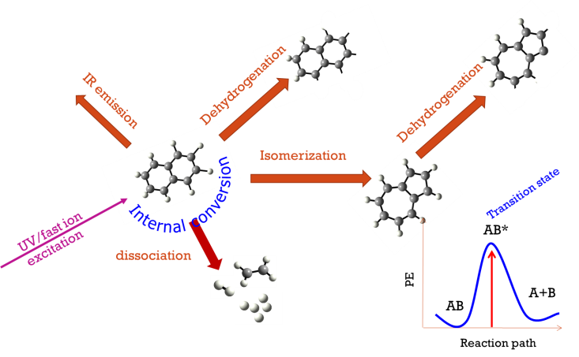

Speaker profile: Prof. Umesh Ramakant Kadhane
- Ph. D. in the field of ion-molecule collisions from TIFR, Mumbai.
- More than three years of experience with ion-storage devices and molecular mass spectrometry at the University of Aarhus, Denmark and University of Paris Sud, Orsay, France.
- Faculty in Physics since 2009, at present Professor and Head, Dept. of Physics, Indian Institute of Space Science and Technology (IIST), Trivandrum, Kerala, INDIA.
- Deputy project director for the High Thrust EPS for LPSC, Indian Space Research Organisation.
- PI of three major space missions of IIST including a successful ARIS mission around Earth (Launched in April 2019), and payloads for upcoming Mars and Venus missions by ISRO.
- He has setup three major research laboratories in IIST, Atomic and molecular physics lab., Electric Propulsion Diagnostics Laboratory (EPDL) and Sensors and payload development laboratory for SSPACE (SPDL-S).

